Collector Ring Signal
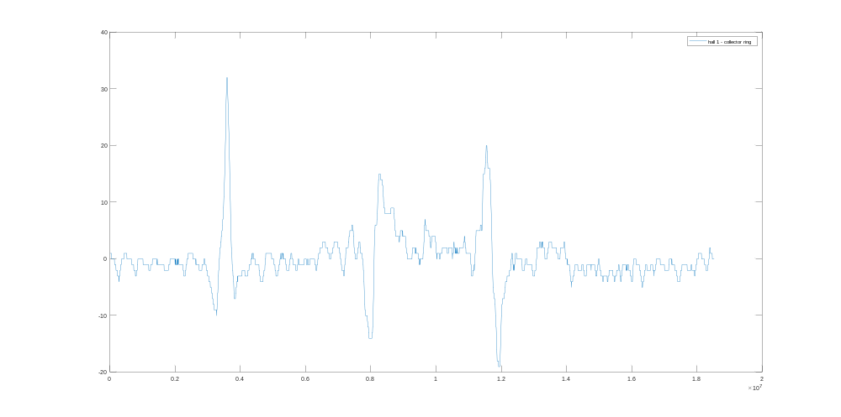
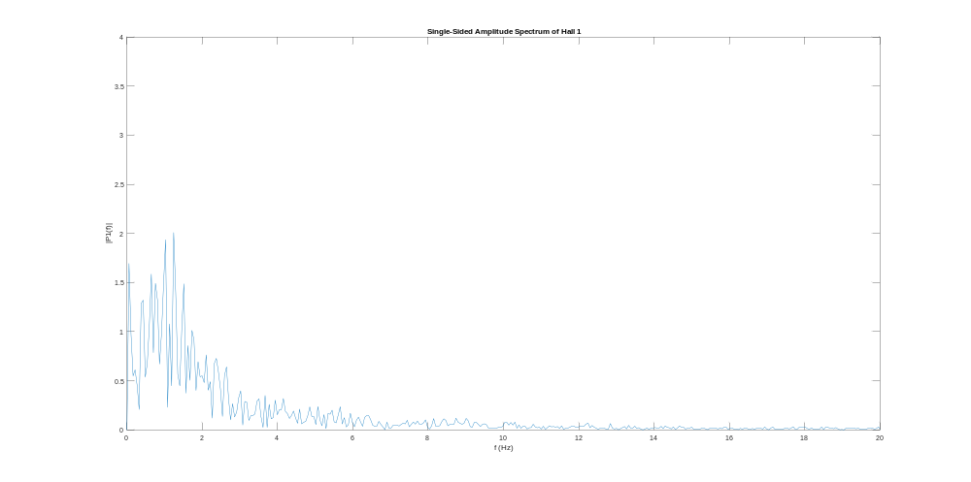
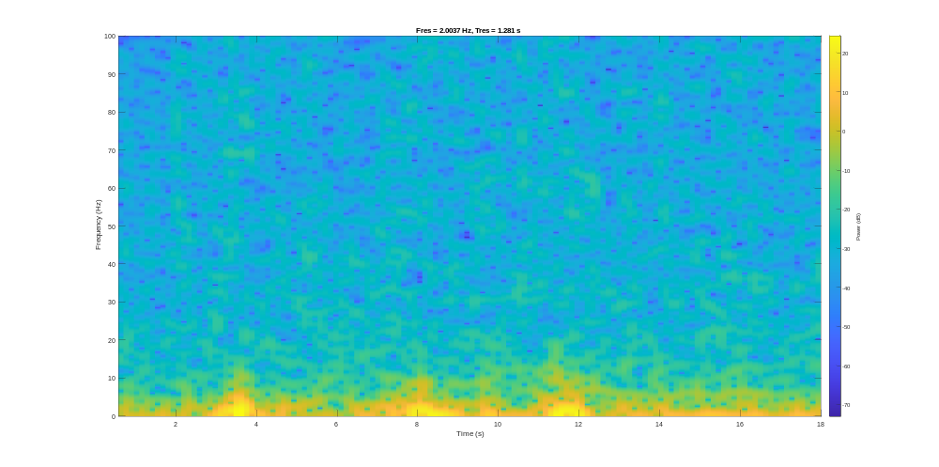
Regular Signal
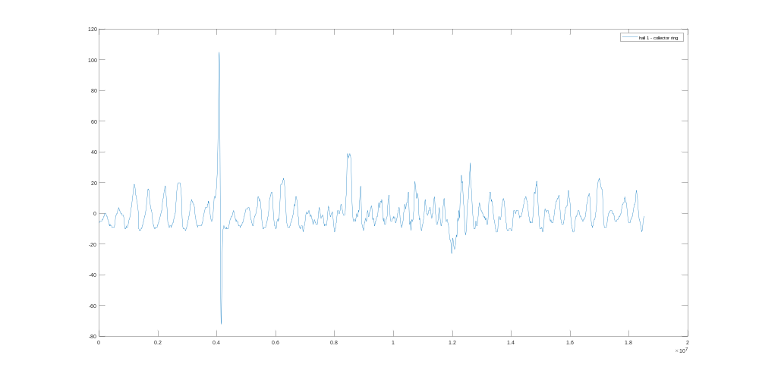
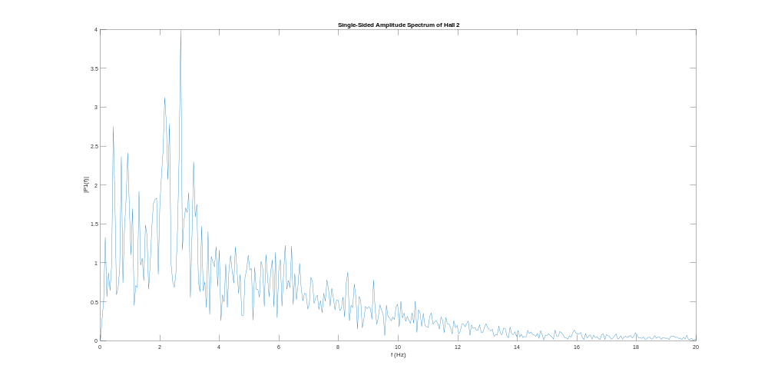
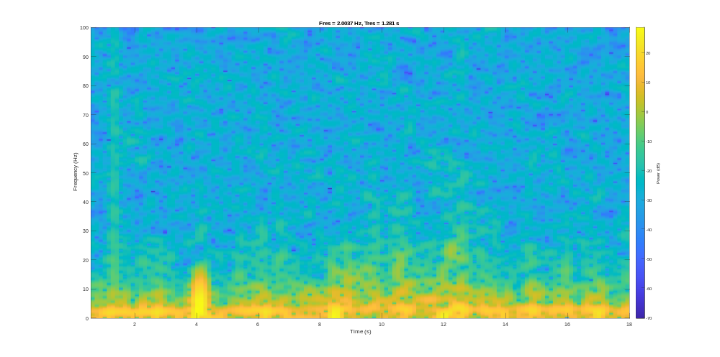
Plot | Collector | Standard
Time | - obvious peak at cut  - obvious peaks at edges of corrosion  - perhaps an above-baseline signal between corrosion peaks | - obvious peak at cut  - less cyclic over region of corrosion (ie/ “messier”)
Frequency | - most power in 0-3 Hz region | - most power in 0-10 Hz
Spectrogram | - bright patches over cut and edges of corrosion | - larger peak at cut  - shift towards higher frequency over corrosion

To do (26/10/22)
- Insert new data into power point
- Remove 3 Hz noise from system
  - Adjust RPM of motor (reduce to 50% of current)
  - Add in extra wheels or change length to reduce “hill” effect

MFL v2 next steps
- When moving MFL v2, it slides over “corroded” bit
  - Roughen up surface
  - Spray with water to help corrosion
- Signal doesn’t look very smooth
  - Increase sample rate of hall effect sensors
  - Get a better ADC (one from Raspberry pi?)
- Collector ring near saturation at all times (sits around 12,000 / 65,000)
  - Switch magnets around to reverse field
    - Just saturates the other way
  - Weaker magnets
  - Greater separation between conductor and magnets
- Improve SNR
  - Move sensor closer to magnets

